Risk Assessment: Rural & Wild Outdoor Training Session

Activity: Short walk during Training Session
Date of activity: Tues 23rd Sept 2025
Date of risk assessment: Tues 26th Aug 2025
Location: St Eds cathedral grounds
Time/frequency: One off session
Review date: N/A

No. | Identified Risk | Assessment of Risk |  |  | Controls Required | Residual Risk
No. | Identified Risk | Likelihood x Consequence = Risk |  |  | Controls Required | Likelihood x Consequence = Risk
1 | Injury caused by slips, trips or falls | 2 | 4 | 8 | Leader to complete pre-walk. Team to remove or highlight potential trip hazards:  e.g. Roots / Uneven ground / Slippy if wet. | 1 | 3 | 3
2 | Weather related illness | 1 | 4 | 4 | Forecast looks fine. Attendees encouraged to wear appropriate clothing / footwear. | 1 | 2 | 2
3 | Bites, stings, scratches etc | 4 | 2 | 8 | Pre-walk to identify how overgrown the route is. Group encouraged to stick to the footpaths. Bite/sting cream in the First Aid Kit. | 1 | 2 | 2
4 | Refreshments (Scalding / Choking / Food poisoning) | 2 | 4 | 8 | Basic Food Hygiene principles followed. Any allergies and intolerances catered for in advance. Hot drinks responsibility of each family group. | 1 | 1 | 1
5 | Car Park / traffic incident | 2 | 4 | 8 | No roads or traffic. Group encouraged to use common sense. | 1 | 2 | 2
6 | [RISK BENEFIT]
7 | [ON THE DAY ADJUSTMENT]
Assessor’s name: Position: Signature:

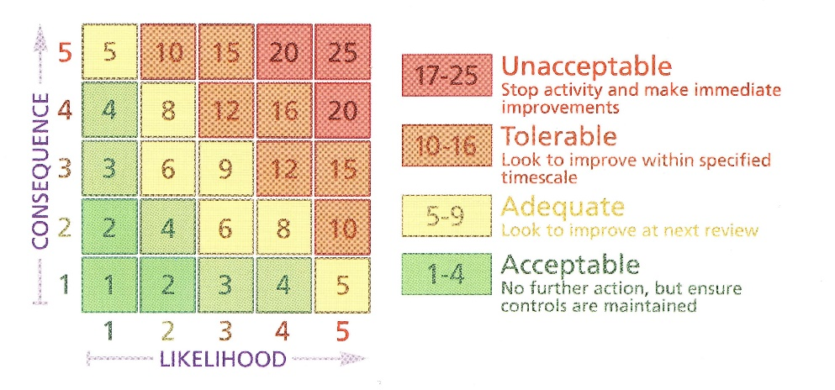
Risk Assessment Matrix

LIKELIHOOD
- Very Unlikely – there’s a 1 in a million chance of the hazardous event happening
- Unlikely – there’s a 1 in 100,000 chance of the hazardous event happening
- Fairly Likely – there’s a 1 in 10,000 chance of the hazardous event happening
- Likely – there’s a 1 in 1,000 chance of the hazardous event happening
- Very Likely – there’s a 1 in 100 chance of the hazardous event happening

CONSEQUENCE
- Insignificant – no injury
- Minor – minor injuries needing first aid
- Moderate – up to three days’ absence
- Major – more than three days’ absence
- Catastrophic - death

